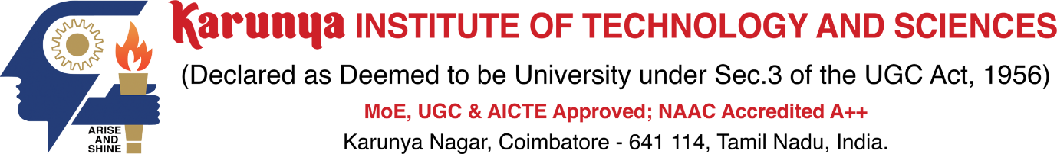

END SEMESTER EXAMINATION – APRIL / MAY 2024

Course Code | IN FULL CAPS | Duration | 3hrs
Course Name | IN FULL CAPS | Max. Marks | 100

Q. No. | Questions |  | CO | BL | M
PART – A (4 X 20 = 80 MARKS)
(Answer all the Questions)
1. | a. |  | CO1 |  | 20
 | b.
 |  | (OR)
2. | a. |  | CO2 |  | 20
 | b.
3. | a. |  | CO3 |  | 20
 | b.
 |  | (OR)
4. | a. |  | CO4 |  | 20
 | b.
5. | a. |  | CO5 |  | 20
 | b.
 |  | (OR)
6. | a. |  | CO |  | 20
 | b.
7. | a. |  | CO |  | 20
 | b.
 |  | (OR)
8. | a. |  | CO6 |  | 20
 | b.
COMPULSORY QUESTION
9. | a. |  | CO6 |  | 20
 | b.

CO – COURSE OUTCOME BL – BLOOM’S LEVEL M – MARKS ALLOTTED

COURSE OUTCOMES
CO1
CO2
CO3
CO4
CO5
CO6

Assessment Pattern as per Bloom’s Level
CO / BL | R | U | A | An | E | C | Total
CO1
CO2
CO3
CO4
CO5
CO6
 |  |  |  |  |  |  | 180

